**Special Operations Regiment Anniversary Parade 18 Oct 22**

**Additional information for VVIP**

**Program**

* 1415hr - Arrival @Castle MLD and coffee
* 1450hr - Designated VVIP’s Ready @Castle MLD & Chapel
* 1500hr - Welcome and Inauguration

Shift to parade

* 1610hr - End of Parade
* 1615hr - Designated VVIP’s @Castle MLD
* 1630hr - Shift to Reception @Wartet

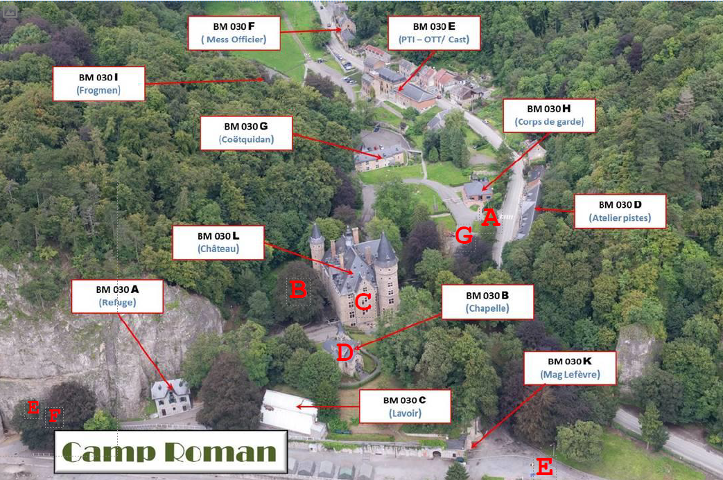**Marche-les-Dames locations**From the guardhouse MLD you will be guided to the parking for VVIP’s.

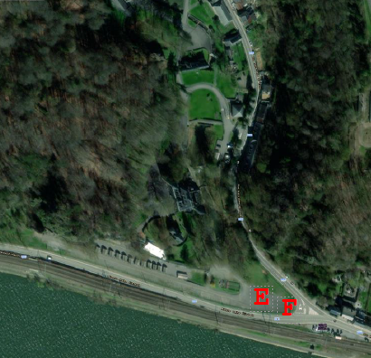

1. Guard MLD
2. Parking
3. Castle
4. Memory Wall @ Chapel
5. Parade Ground MLD
6. PUP & DOP Bus Shuttle @ Back Gate
7. Parking other VVIP = MOD, CHOD, LCC and special selected Pers…

**Dress Code**

Military (2B) – Civilian (Jacket and Tie)

**Informations**

• If you want additional information, you can always contact us, either:

* + Via mail: HQSOREGT-Srt@mil.be
  + Via Tel : +3224434514