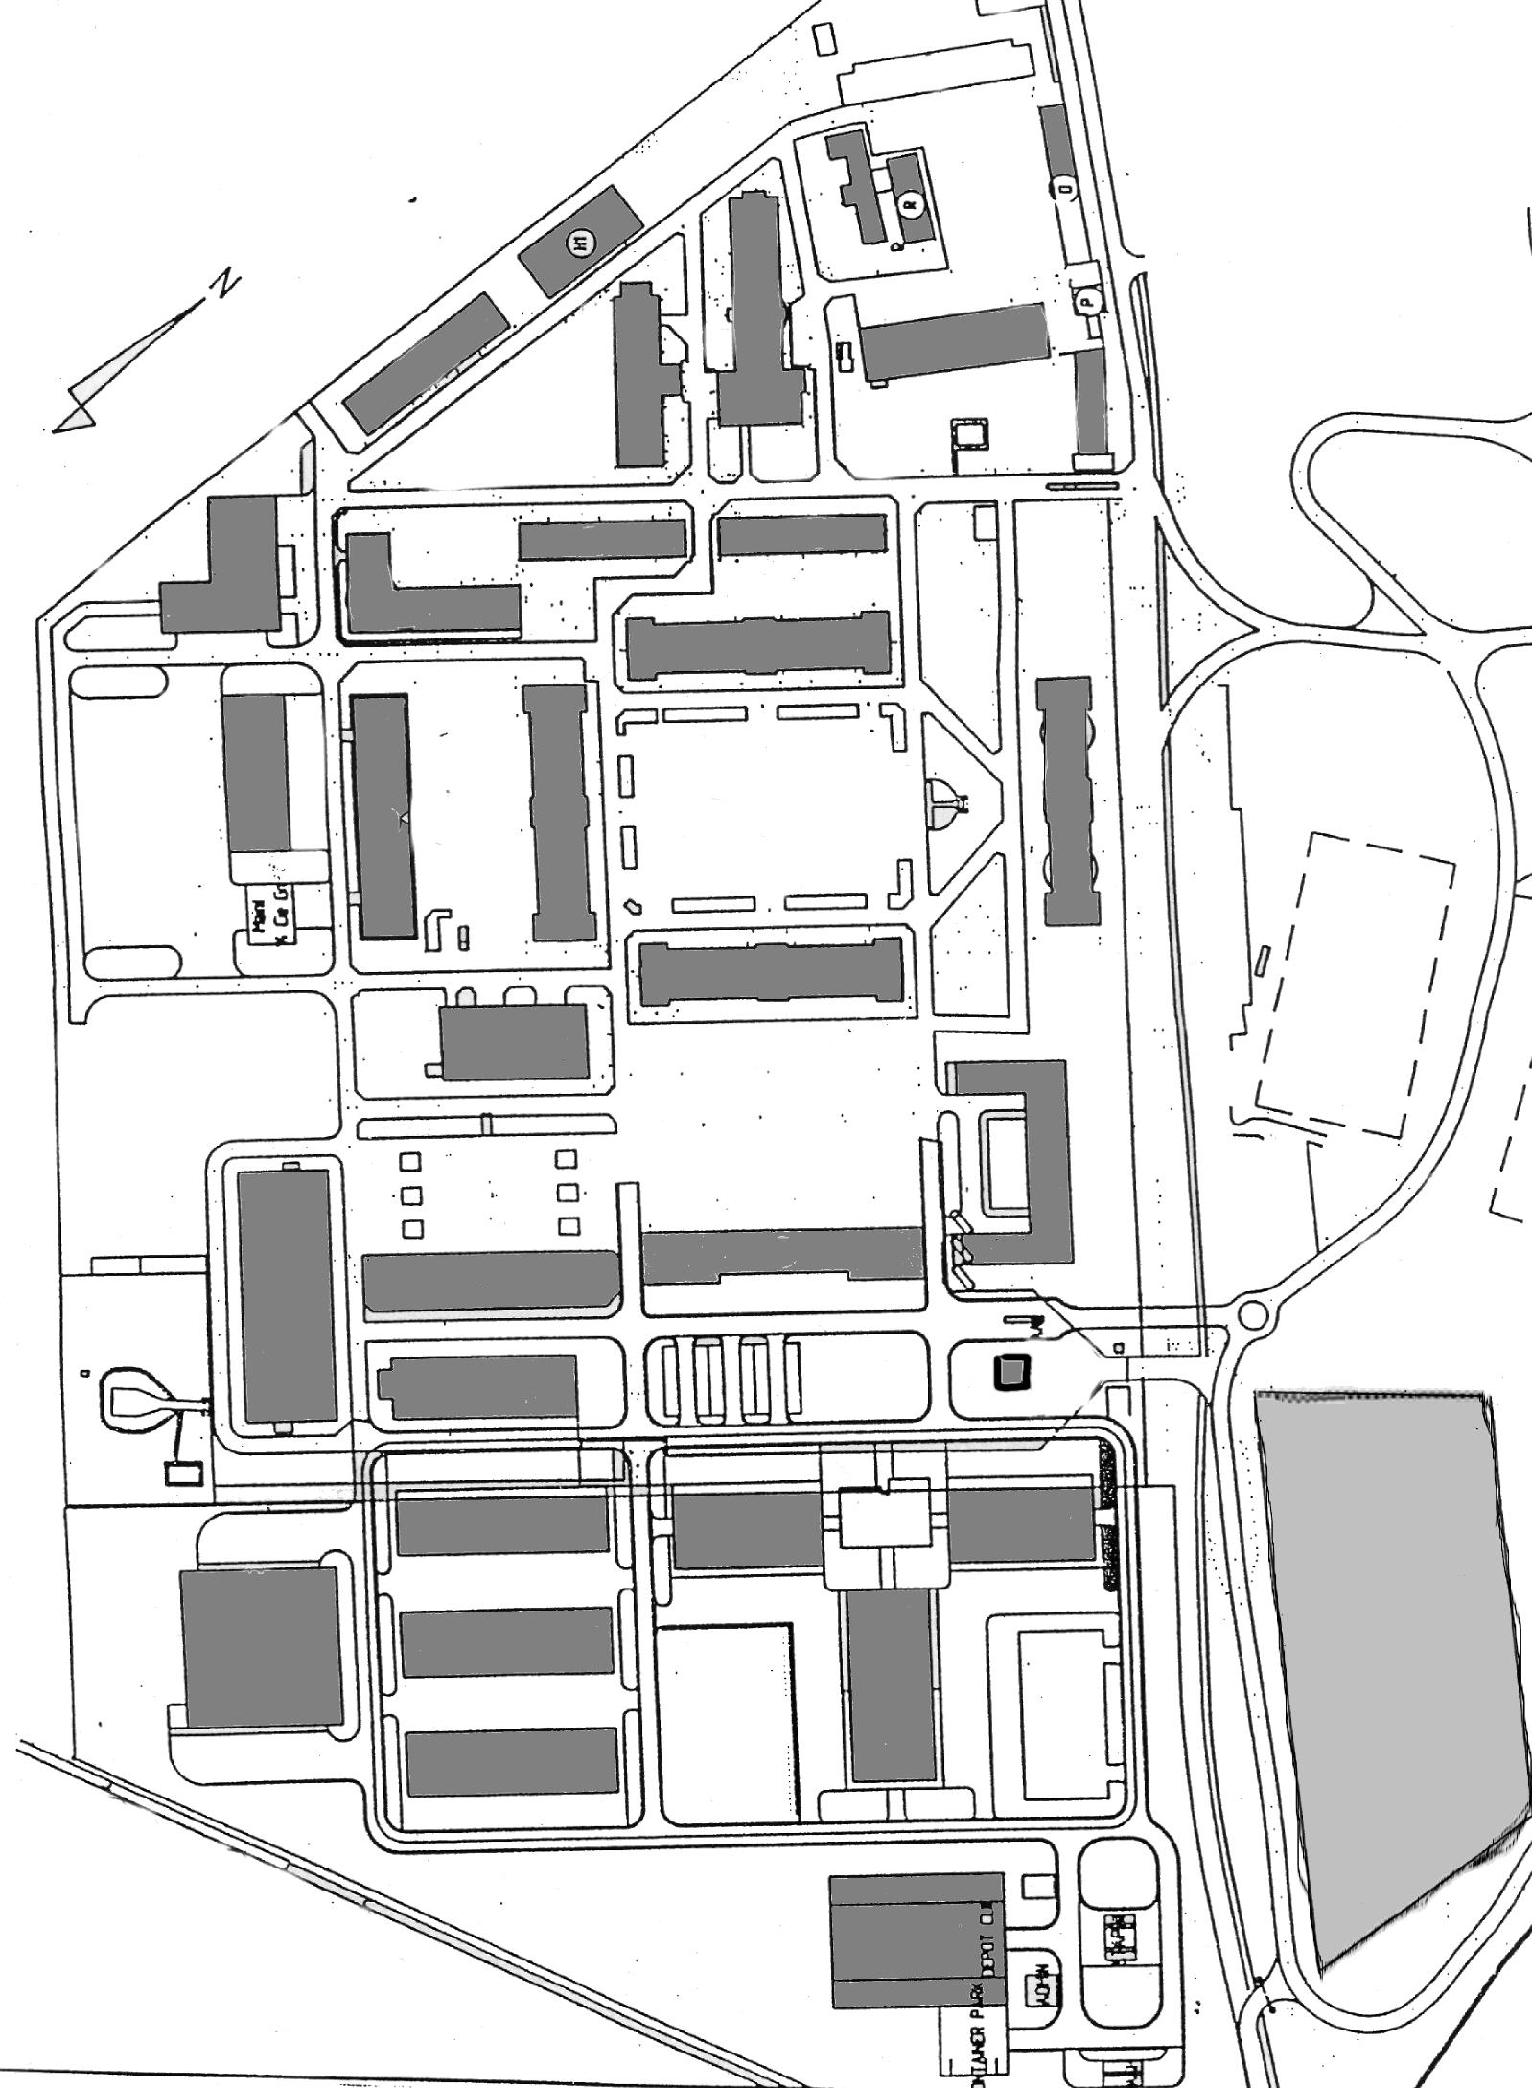
2
4

1

3

- Parking 2. Parking VVIP 3. Guard House 4. Salle/Zaal

